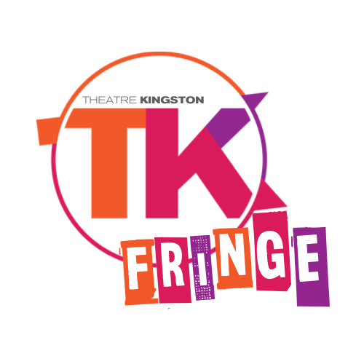

TK FRINGELOTTERY and APPLICATION
TK FRINGE DATES: Aug 1- 11, 2024 FOR 18 SPOTS
Congratulations! You are taking a chance on you! We wish you the best of luck and will be thrilled to have you join the Theatre Kingston Storefront Fringe 2024! DEADLINE: 6:00pm (EST) Friday February 23, 2024

Lottery to be pulled Sunday FEB 25 5pm 2024 in the Lobby of the Baby Grand Theatre

after the final matinee of Bakersfield Mist.
PLEASE FILL OUT THE FOLLOWING APPLICATION AND CONTRACT:

TITLE OF SHOW (optional, not final): Company/ Collective name and location: Contact Person: TELEPHONE: EMAIL: ADDRESS: CITY: PROVINCE: POSTAL CODE

Admin Lottery Fee
(Non-refundable.):
$25 +HST = $28.25

Festival fee
to be Processed upon acceptance to festival, refundable until May 1 2024
$350+HST = $395.50

LOTTERYCATEGORYPLEASE CIRCLE : local/ outoftown/ localTYA / outoftownTYA/ localdiverse/ outoftowndiverse To be included in the diversity lottery please attach one paragraph that speaks to your company’ s artists as underrepresented. Entrance into the diversity lottery does not require an additional fee.
Diversity Statement:

FESTIVAL CONTRACT: I (CONTACT) On behalf of my performing company, I acknowledge that:

- Upon winning a spot from the lottery, and once my Festival Fee is deposited and my application accepted, I will be permitted to perform in the 2024 Theatre Kingston TK FRINGE FESTIVAL ("the Festival"); I will have the right to a theatre space, technical equipment, box office services, and general festival publicity without any further charges;
•Once my show is accepted into the Festival, my application fee is not refundable for ANY reason after May 15, 2024;
•It is my responsibility to secure all rights and pay all royalties,taxes for my production; and to provide proof of such on demand by the Festival;
•It is my responsibility to obtain permission to perform from any professional associations to which my artists belong;
•I agree to adhere to the laws of Canada and Ontario, the by-laws of the City of Kingston, and the policies and procedures of the TK FRINGE and Theatre Kingston.
•I agree that the Theatre Kingston TK Fringe reserves the right to remove anyone or company that contributes to an unsafe environment and this include company members who refuse to abide by covid protocols during the festival.
The TK FRINGE will not knowingly produce a show without the permission of its originator(s). You are obliged to obtain written permission from the playwright/author/originator and pay any fees required for the production rights. Additionally, you are required to obtain written permission from the necessary sources for the use of any material protected by copyright that is used in the production or promotion of your show (ex: photographs, music, etc.) Failure to do so could result in disqualification without refund or written notice. Cancellation of your show due to lack of permission(s) or rights to your show or any materials used the production or promotion of your show will result in forfeiture of your entire application fee.
The Festival reserves the right to cancel any performances of companies not adhering to this agreement. If your company is accepted into the Festival, this application will be considered a signed agreement between you and the Festival.

Date Signature of Contact Person

Payment MethodPlease Circle: Cash/ Cheques/ Money Order/ MADE PAYABLE TOTHEATRE KINGSTON

Credit Card MC / VISA # EXP.: CVV (3 digits on back):

Office Use Only : Lottery
Festival Fee

Send to Theatre Kingston Suite 111 370 King Street West Kingston, Ont K7L 2X4 email rosemary@theatrekingston.com
Amount
/

